COMPUTER ASSINGNMENT

ICS 2240

GROUP MEMBERS

1. SICHAMBO KIRUI WISELY HSB214-0098/2022
2. LYDIA MINAYO HSB214-0459/2022
3. MICHELE ADHIAMBO HSB214-0460/2022

JOMO KENYATTA UNIVERSITY OF AGRICULTURE AND TECHNOLOGY

BSC. MEDICAL BIOCHEMISTRY

**EXPLORING NATURE`S HIDDEN TREASURES**

N

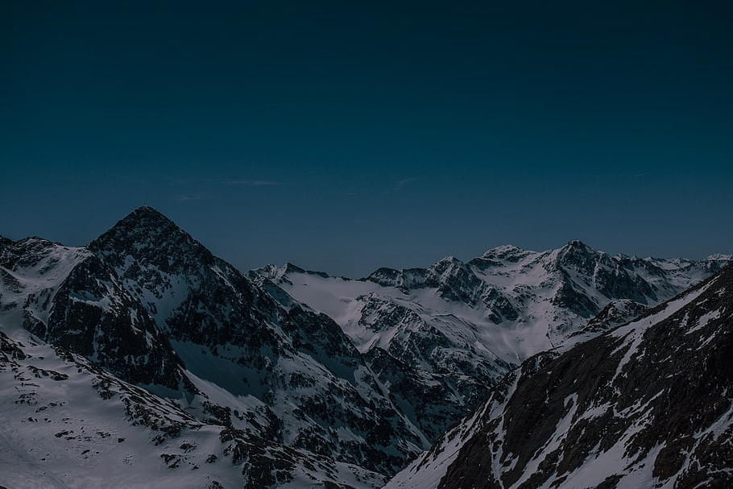estled in the heart of East Africa is a country of amazing beauty, a tapestry woven by nature's most talented hand. Kenya is a breathtaking natural wonder that calls with an attraction that enthralls visitors and leaves onlookers in amazement. Kenya's natural splendor soothes the spirit, from the snow-capped summits of Mount Kenya to the flowing golden savannahs of the Maasai Mara.

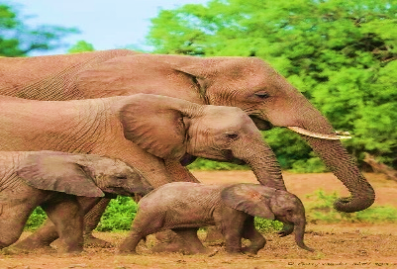The Amboseli National Park awakens at dawn as the first African sun caresses the landscapes, and the unmistakable silhouette of elephant's parades against the backdrop of the massive Mount Kenya. It is a vision of majestic grace that dehumanizes the viewer, a symphony of giants that lavishly decorates nature's canvas.

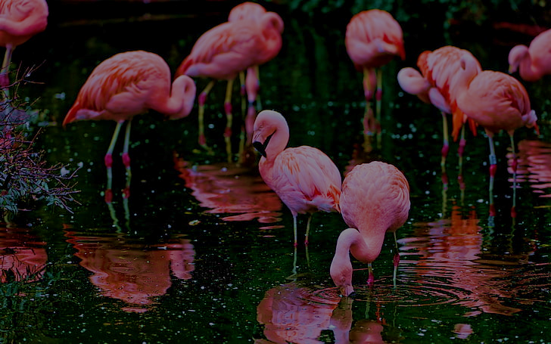

With the captivating flamingos of Lake Nakuru and the emerald waters of Lake Naivasha, the Great Rift Valley appears to us like an old scar on the surface of the Earth. Brimming with life, these freshwater oases serve as a testament to both the harmonious dance of nature's creations and Kenya's unparalleled biodiversity.

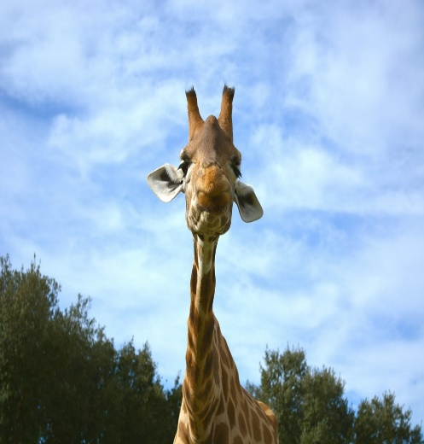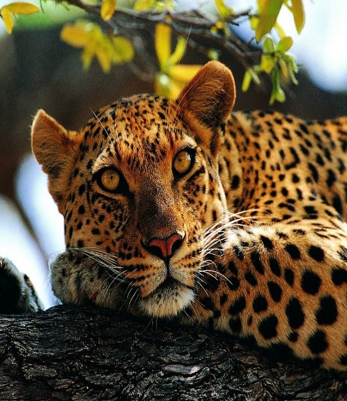Go even farther north to Samburu's unique landscapes, where the Ewaso Nyiro River meanders through arid desolation, beckoning a magnificent assembly of animals, including;

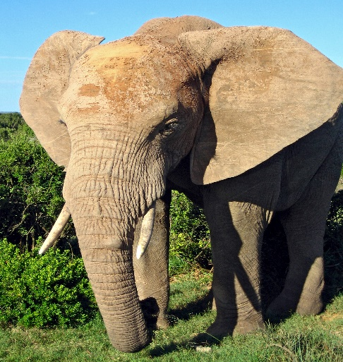

[This Photo](https://commons.wikimedia.org/wiki/File:African_Elephant.jpg) by Unknown Author is licensed under [CC BY-SA](https://creativecommons.org/licenses/by-sa/3.0/)

* Lions
* Elephants
* Giraffes
* Rhinos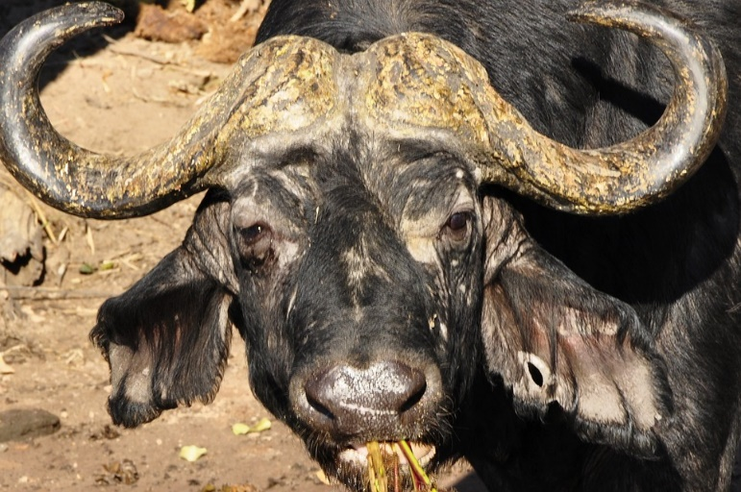
* Cheater
* Gazelles

The Laikipia Plateau, a patchwork of private conservancies, is a perfect example of how people and wildlife can coexist, with local communities and conservationists acting as land stewards. Gazelles and rhinoceroses coexist on the grazing land, demonstrating how Kenya's natural beauty and its dedication to protecting the planet's most valuable assets go hand in hand.

However, we must not overlook the azure depths of the Indian Ocean, where the Lamu archipelago is encircled by a kaleidoscope of coral reefs, providing a world below the waves that rivals the wonders above.

Beauty is not just seen but felt all over Kenya; it permeates your spirit and is pulsating with the pulse of this amazing country. Kenya is a country of contrasts and harmonies, where the tranquil and the wild, the old and the modern, come together to create a magnificent work of art that nature's brush has created, leaving a lasting impression on everyone who is lucky enough to experience its ethereal allure.

Kenya is well known for its breathtaking national parks, each with its own distinct wildlife and scenery. Kenya has several significant national parks, including:

1. Maasai Mara National Reserve
2. Amboseli National Park
3. Tsavo National Parks (Tsavo East and Tsavo West)
4. Samburu National Reserve
5. Lake Nakuru National Park
6. Nairobi National Park

The approximate distribution of big 5 animals in the biggest parks in Kenya is as follows:

|  |  |  |  |  |  |
| --- | --- | --- | --- | --- | --- |
| **NATIONAL PARK** | **LION** | **LEOPARDS** | **ELEPHANTS** | **RHINOCEROUS** | **BUFFALOS** |
| MaasaiMara National Reserve | 450 | 120 | 380 | 50 | 950 |
| Amboseli National Park | 220 | 80 | 1500 | 10 | 420 |
| TsavoEast National Park | 700 | 100 | 1300 | 50 | 850 |
| TsavoWest National Park | 450 | 90 | 2100 | 40 | 950 |
| **TOTAL** | **1820** | **390** | **5280** | **150** | **3170** |

Following the arrangements made by the mother nature organization, the selected members of the team will be visiting the country the following month. Their invitation letter is as follows

Dear Mr. Brian Nderitu,

I hope this letter finds you well. We extend a heartfelt invitation to join us for a Mother Nature tour in Kenya from November 11th to November 21st, 2023. We'll explore Kenya's stunning landscapes, from the Maasai Mara's savannahs to Amboseli's elephants against Mount Kilimanjaro's backdrop. The Great Rift Valley, Samburu, Laikipia, and the coral reefs of Lamu await. We wish you a journey filled with wonder and the kindest of mercies from Mother Nature.

Please let us know your response soon. We look forward to sharing this extraordinary experience with you.

Warm regards,

Mike